**Group 1**

**Mohd. Akbar Nabi**

**Sonam Sharma**

**Harsh Patel**

Custom Close Contractors: Making the database cut

1. **What is the main operational problem C3 is facing?**

The main issue that C3 was facing is Poor data management. Not using electronic database, all their information stored in pages which was so clumsy. There was no database to store client information. Talking in terms of revenue, with more documentation and no centralized database they almost cost half of their productivity and costing the company half of their fortune. Following the old version, C3 was paying more than their benefits. Maximum part of their communication is based on the repeated information due to lack of organized data of the company. Sometimes miscommunication results in consequently increase in likelihood of errors. The severity of issue was to the extent that design consultants sometimes failed to record important information about customers, as well as production staff accidentally followed old version of a job’s cutting lists.

1. **Would an Excel Spreadsheet be sufficient in this case? When is the right time to invest in a database?**

Considering the client-customer relationship involved in C3, an excel spreadsheet won’t be enough to create and maintain the information. C3 requires more powerful database to store all the information and fetch the information when required. An excel spreadsheet would only contain information about an attribute but not the relation between them which would again increase unproductive time for the employees. Creating a database would provide a secure platform to capture all their company’s data and with the use of cloud technology results in diminishing the risk of losing their data and will able to back up their data when required. Also, with multi-disciplinary database, numerous users can access the database at the same time from different places. A good and managed database could impose rules and constraints greatly improving data integrity. Excel spreadsheet does not have these capabilities.

The sooner to invest in database the better it will be. Building a database at the early stage of a company enables it to store its data that would be used for future decision making and avoid errors. Also, once the company expanded it is difficult and costly to design and built database for a large company, especially when the company has several departments each with complex operational processes and their isolated data storages.

1. **What questions could C3's administrative staff answer with a database? What about the production staff?**

With the proper Database, C3 administrative staff could provide customers general information like name, email address, phone number, street address and referral which is important part to get company revenue. It can also provide the important information from the customers who works in similar industry like their company name, email or website address. Administrative staff would also be able to answer the consultation details of the customer and designer based on customer needs.

While on the other hand side production staff would be able to handle technical information like quote and the installation process by proper communication with administrative staff about date, time an address of the place which requires installation.

1. **After reading through a description of the business processes, create a list of entities and attributes that could be used in a potential data model. What are the relationships between entities?**
2. Customer: customer ID, Email Address, phone number, street address(o), customer name (first name, last name)
3. Potential Customer: Potential customer ID, Customer Details
4. Company: Company ID, Company Name, Email address, website address, type of account, phone number
5. Designer: designer ID, designer Name
6. Consultation: Consultation ID, location, Consultation date, Consultation time,
7. Quote: Quote ID, Notes, Quantity, quotes accepted, total amount, taxes, discount rate(o)
8. Installation: Installation ID, installation date, installation time, installation address
9. Installer: Installer ID, installer name, contact info
10. Unit: Unit ID, unit name, price

Relationships:

Potential Customer to Customer 🡪 Many to one

Customer to Potential Customer 🡪 One to many

Customer to Company 🡪optional many

Company to Customer 🡪 Mandatory one

Customer to Consultation🡪 Optional Mandatory

Consultation to Customer 🡪 Mandatory one

Quote to Consultation 🡪Mandatory one

Consultation to Quote 🡪 Optional one

Consultation to Designer 🡪Mandatory one

Designer to Consultation 🡪 Mandatory Many

Quote to Installation 🡪Mandatory Many

Installation to Quote 🡪Mandatory one

Installation to Installer🡪Mandatory Many

Installer to Installation 🡪Mandatory one

Quote and Unit 🡪 Many to Many

1. **Design an ER model with the entities,attributes and relationships that you listed using the ERDplus software**

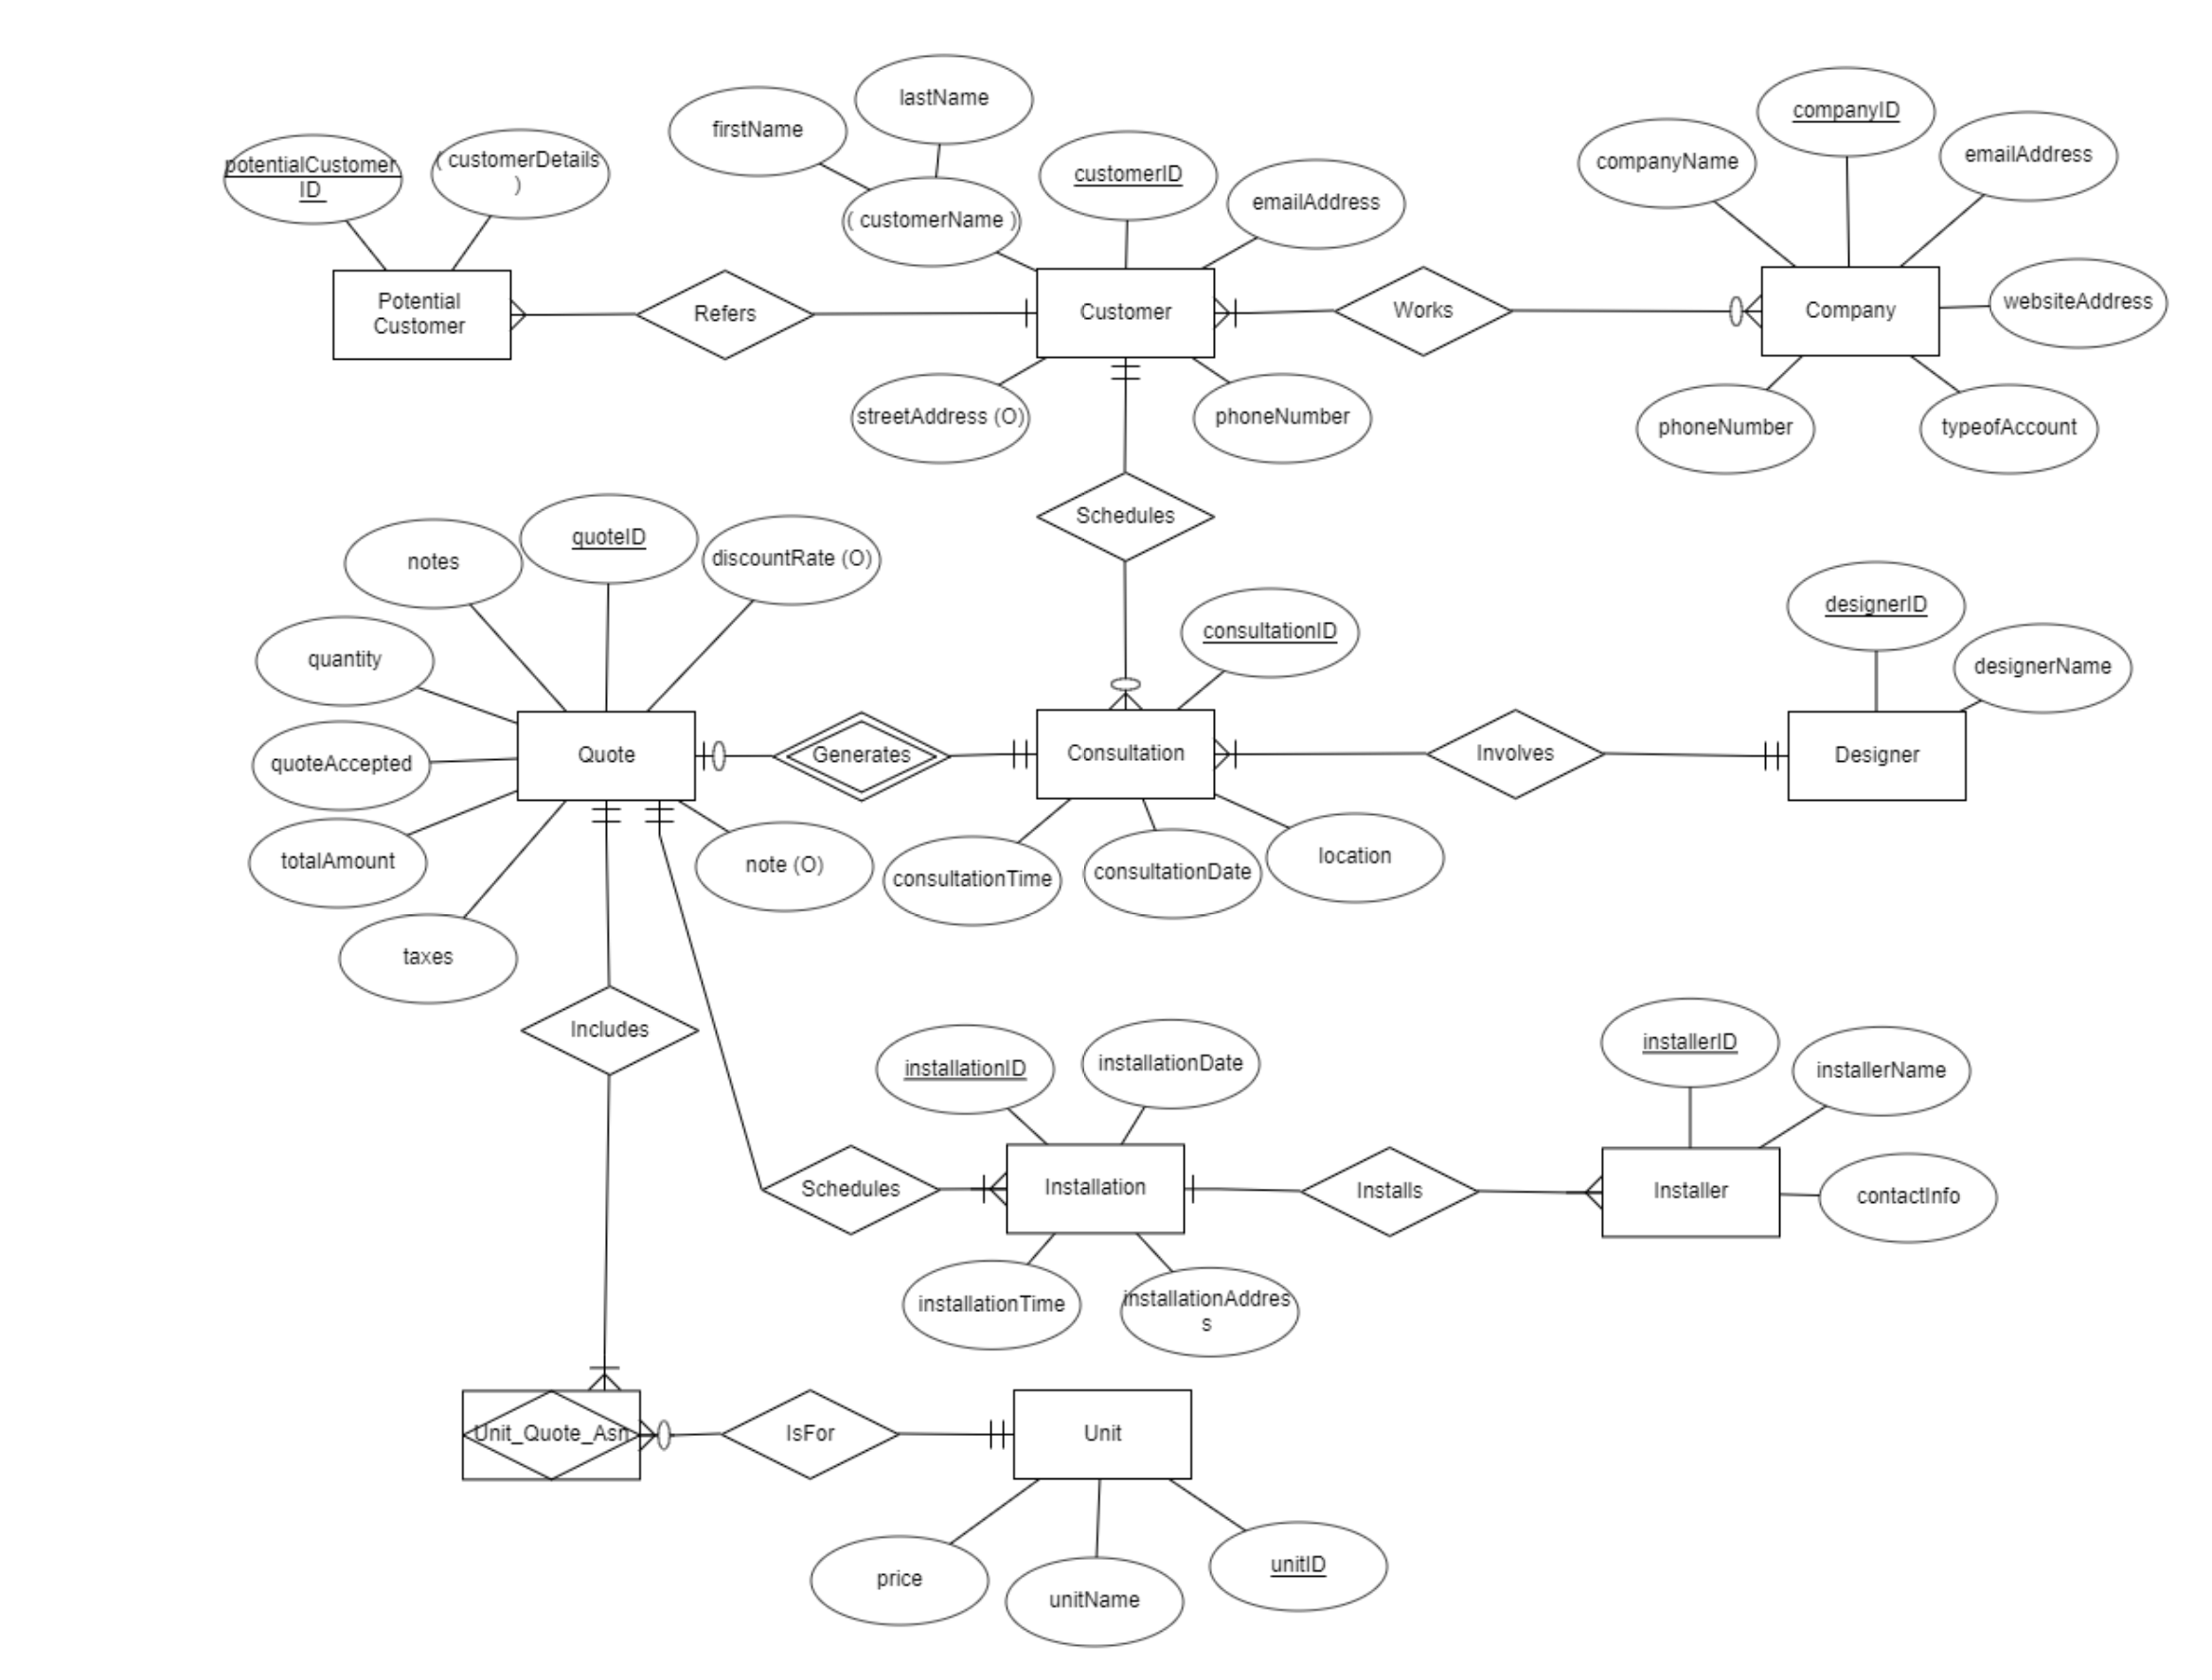

1. **Show the list of the final tables along with the table columns and the primary keys.**

|  |  |  |  |  |  |  |  |
| --- | --- | --- | --- | --- | --- | --- | --- |
| Customer | | | | | | | |
| Customer ID | First Name | Last Name | Street Address | Schedules | Phone Number | Email Address | Company ID (FK) |

|  |  |  |
| --- | --- | --- |
| Potential Customer | | |
| Potential Customer ID | Customer Details | Customer ID (FK) |

|  |  |
| --- | --- |
| Designer | |
| Designer ID | Designer Name |

|  |  |  |
| --- | --- | --- |
| Unit | | |
| Unit ID | Unit Name | Price |

|  |  |  |  |  |  |
| --- | --- | --- | --- | --- | --- |
| Consultation | | | | | |
| Consultant ID | Location | Consultation Date | Consultation Time | Customer ID (FK) | Designer ID (FK) |

|  |  |  |  |  |  |
| --- | --- | --- | --- | --- | --- |
| Company | | | | | |
| Company ID | Company Name | Phone Number | Type of Account | Website Address | Email address |

|  |  |  |
| --- | --- | --- |
| Installer | | |
| Installer ID | Installer Name | Contact Info |

|  |  |  |  |  |  |
| --- | --- | --- | --- | --- | --- |
| Installation | | | | | |
| Installation ID | Installation Date | Installation Address | Installation Time | Quote ID (FK) | Installer ID (FK) |

|  |  |  |  |  |  |  |  |  |  |
| --- | --- | --- | --- | --- | --- | --- | --- | --- | --- |
| Quote | | | | | | | | | |
| QuoteID | Discount rate | Note | Taxes | Total Amount | Quote Accepted | Quantity | Notes | Consultation ID | Unit ID(FK) |

1. **Create some tables in MySQL (select some).**

create database c3;

use c3;

Create table Customers(

CustomerId INT Not Null unique Primary Key,

CustomerFirstName Char Not Null,

CustomerLastName Char Not Null,

Email Varchar(50) Not Null,

PhoneNumber Int Not Null,

StreetAddress Char(50),

CompanyID Int unique,

Constraint Customers_fk

Foreign Key (CompanyID)

References Company(CompanyID)

);

Create table Company(

CompanyId Int Not Null unique Primary key,

ComapanyName Char Not Null,

EmailAddress Varchar(50) Not Null,

Website VarChar(100) Not Null,

Phone Int Not Null,

AccountType Varchar(50) Not Null

);

Create table Consultation(

ConsultationID Int Not Null unique Primary Key,

Location VarChar(100) Not Null,

ConsultationDate Date Not Null,

ConsultationTime Time Not Null,

CustomerID Int Not Null unique,

DesignerID Int Not Null unique,

Constraint Consultation_fk

Foreign Key (CustomerID)

References Customers(CustomerID)

Foreign Key (DesignerID)

References Designer(DesignerID) );

|  |  |  |
| --- | --- | --- |
| From | To | Relationship |
| Potential Customer | Customer | Many to one |
| Customer | Potential Customer | One to many |
| Customer | Company | Optional Many |
| Company | Customer | Mandatory one |
| Customer | Consultation | Optional Many |
| Consultation | Customer | Mandatory one |
| Quote | Consultation | Mandatory one |
| Consultation | Quote | Optional one |
| Consultation | Designer | Mandatory one |
| Designer | Consultation | Mandatory Many |
| Quote | Installation | Mandatory Many |
| Installation | Quote | Mandatory One |
| Installation | Installer | Mandatory Many |
| Installer | Installation | Mandatory one |
| Quote | Unit | Many to MANY |